2025-2026

Name of the Event: Workshop on cultivation of medicinal mushrooms
Organised by: IIC, HRC in collaboration with Botanique: The Botanical Society
Date of the Event: 6th November, 2026
Duration/Event Timing: 1:00 PM onwards
Venue of the Event: Room No. A1
Name of Coordinator(s): Dr. Savita and Prof. Monika Koul
Name of Convener: Dr. Romila Rawat Bisht
The Institution’s Innovation Council (IIC) and the Botanical Society ‘Botanique’ of Hansraj College collaboratively organized a highly engaging workshop on the cultivation of edible and medicinal mushrooms on November, 6, 2025. With an enthusiastic gathering of around 100 participants, Students and faculty learned about sustainable cultivation. of mushrooms, with hands -on experience. Dr. Savita Singh from the Department of Botany inaugurated the session with insightful opening remarks, emphasizing the relevance of mushroom cultivation in contemporary agriculture and sustainable practices.
The workshop’s central theme revolved around innovative cultivation techniques and the medicinal properties of mushrooms. The session was led by Mr. Omprakash Dagar, a proficient cultivator and owner of O.P. Mushroom Farm, Malikpur, New Delhi, who brought with him an impressive experience of thirty years in the field. Mr. Dagar detailed the various species of medicinal and edible mushrooms such as Shiitake, Reishi, and Oyster, and highlighted their therapeutic benefits and commercial relevance.
Emphasizing environmental sustainability, Mr. Dagar explained how mushroom farming turns agricultural waste—like straw and sawdust—into valuable substrates, thus promoting eco-friendly agricultural recycling. He discussed the pivotal role of substrates and the importance of environmental parameters such as temperature, humidity, and ventilation in ensuring successful cultivation. Importantly, the sustainable reuse of spent mushroom substrate as an organic fertilizer was presented as a means to enrich soil health and minimize agricultural waste. He added how mushroom cultivation can also support other farm activities.
A special feature of the workshop was the hands-on training session, where Mr. Dagar and his team provided practical demonstrations on substrate preparation, sterilization, spawning, and environmental management, allowing participants to directly engage with the intricacies of mushroom growing. Mr. Dagar extended an open invitation to students to visit his farm for deeper experiential learning. He also inspired participants by discussing entrepreneurship opportunities in mushroom cultivation, the role of effective marketing, and the indispensable value of dedicated effort for building successful, sustainable agri-business ventures.
The program was smoothly coordinated by Dr. Romila Rawat (Convener, Botanique), Dr. Sahil Mehta (Co-convener, Botanique), Prof. Monika Koul, and Dr. Savita, with overall guidance by Prof. Ishwar Singh (Teacher In-Charge). The workshop offered a perfect blend of scientific knowledge, practical training, environmental consciousness, and entrepreneurial motivation, greatly benefiting all attendees, particularly the students. Mr Dagar also provided some specimens of mushroom and substrate to the centre for propagating the mushrooms.
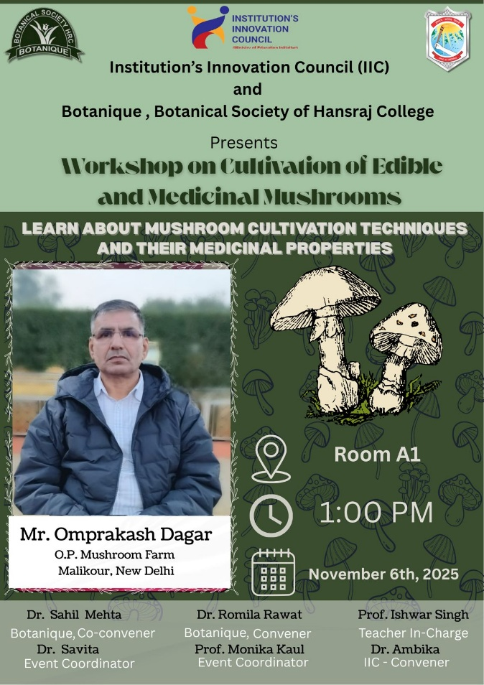

Five Geo-tagged Pictures:
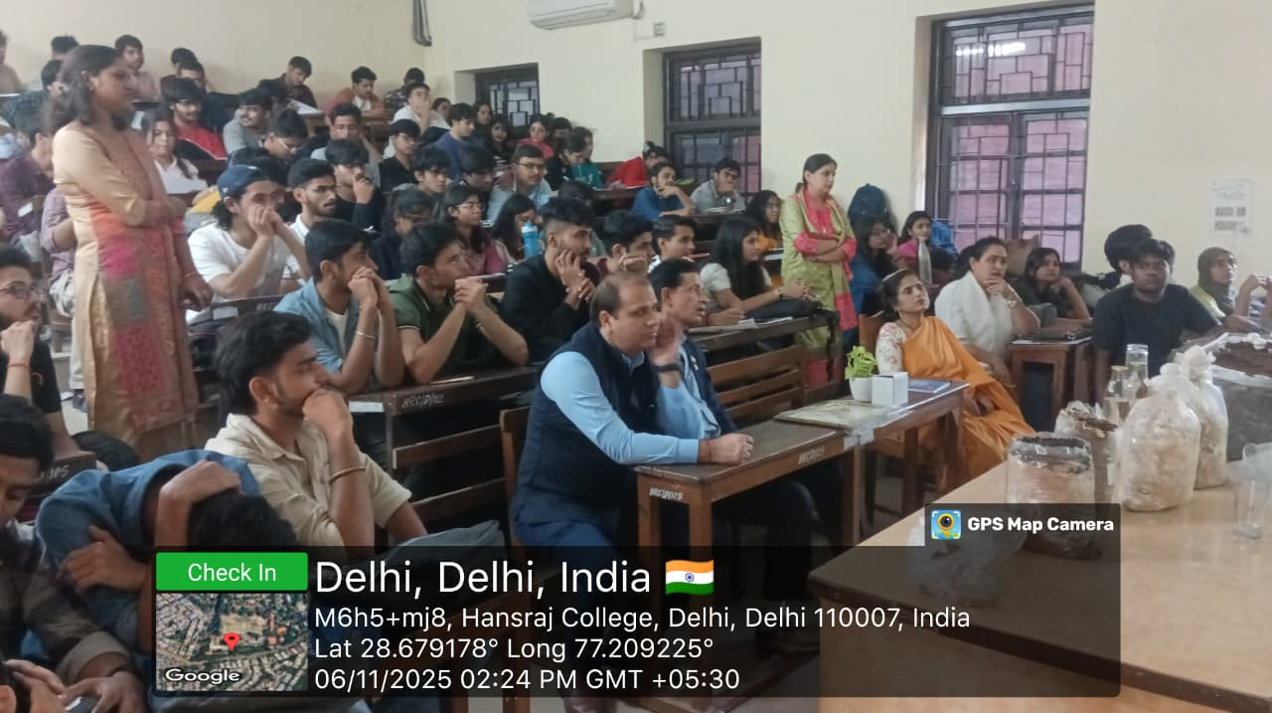
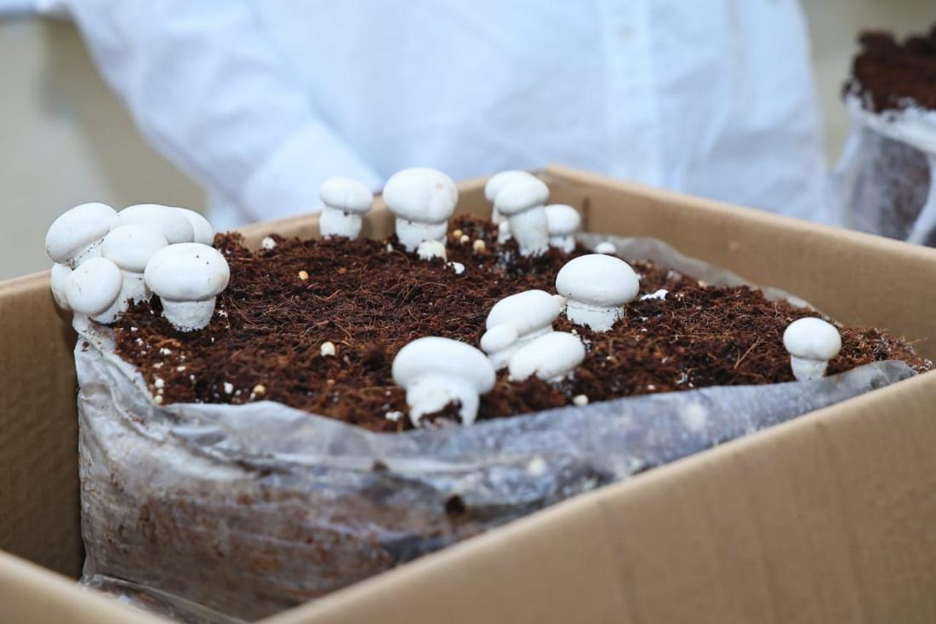
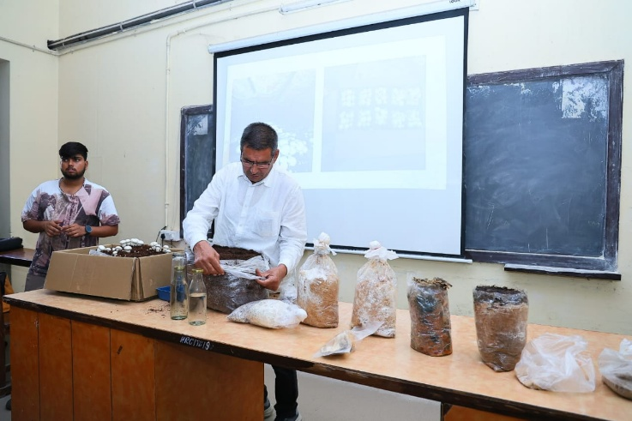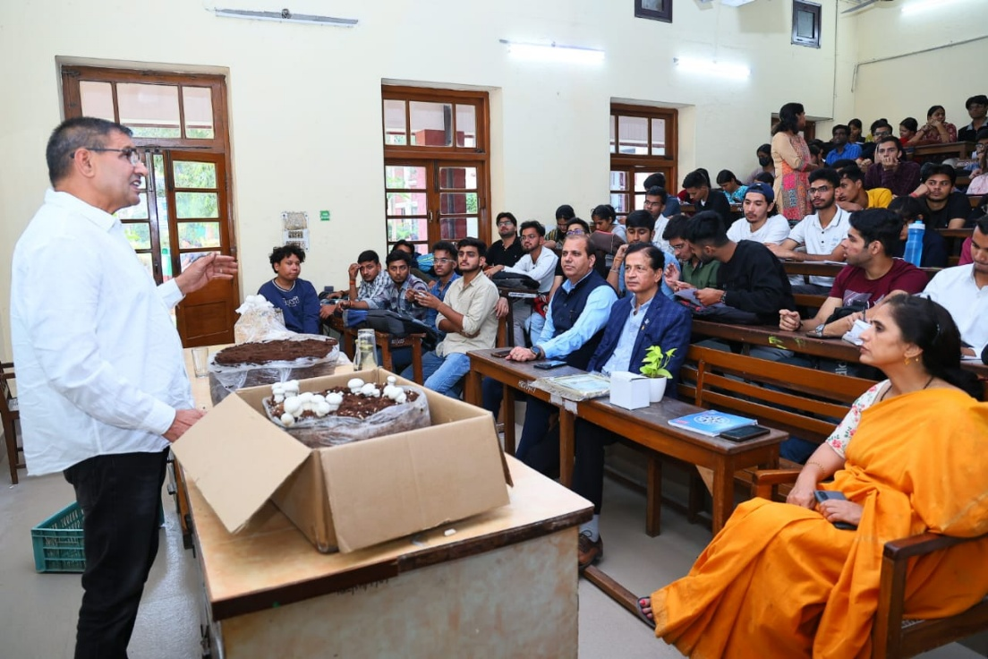
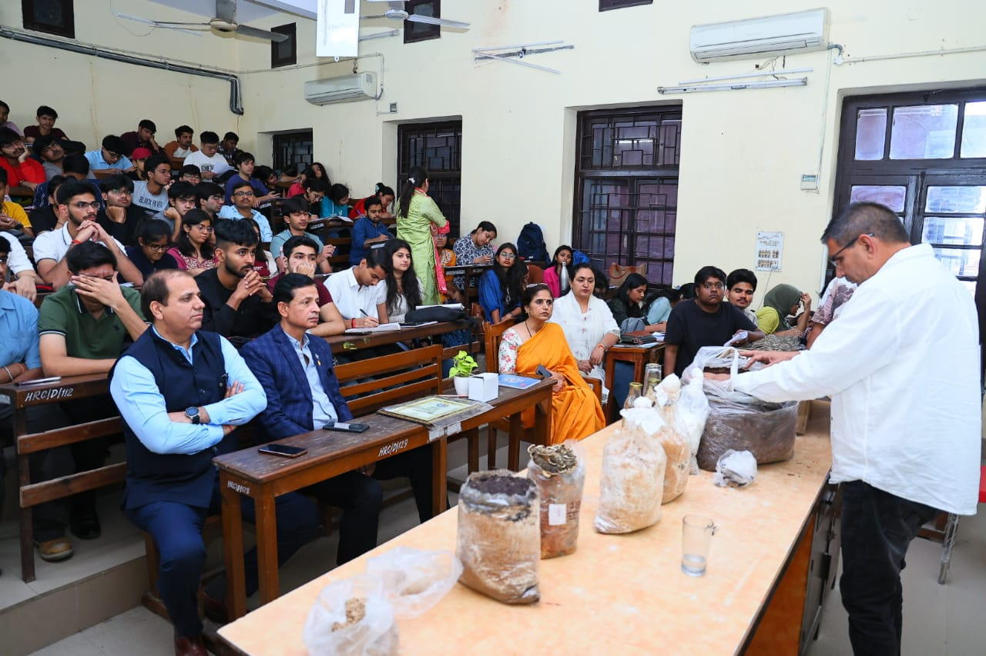

Attach Attendance Sheet